Pneumonia Chest X-Ray Detection Model

Ojasvi Sharma

Department of Computer Science and Engineering

Jaipur Engineering College and Research Centre Foundation, Jaipur – 302022

Jaipur, India

Email

Ms. Anju Rajput

Department of Computer Science and Engineering

Jaipur Engineering College and Research Centre Foundation, Jaipur – 302022

Jaipur, India

Email

Nitin Malav

Department of Computer Science and Engineering

Jaipur Engineering College and Research Centre Foundation, Jaipur – 302022

Jaipur, India

Email

Nipun Jain

Department of Computer Science and Engineering

Jaipur Engineering College and Research Centre Foundation, Jaipur – 302022

Jaipur, India

Email

**ABSTRACT** – The disease Pneumonia is a lung disease that is a result of respiratory infection especially in children, caused by either of the three being bacteria, virus or fungus. It is an interstitial lung disease which results in progressive scarring of tissues of the lungs hence our ability to breathe gets affected which further depletes the oxygen levels in our bloodstream. The disease is highly prevalent in underdeveloped as well as developing countries due to presence of unhygienic environment, high levels of pollution and over-population. Chest X-Ray method is the radiological method used to detect Pneumonia disease by locating the part of lungs infected. It has become a rather challenging task to locate radiological examiners in a lot of remote places that can analyse a big chest x-ray data. To solve this issue, artificial intelligence as well as its approaches such as the use of Big data, CNN, etc are used for the classification and interpretation of the chest x-rays of lungs infected with pneumonia.

Index Terms – Artificial Intelligence, CNN, Deep Learning.

1. **INTRODUCTION**

Due to respiratory infections in individuals after the effect of Covid-19, the lung disease Pneumonia is becoming highly prevalent in today’s times, especially in developing as well as under developed countries. The symptoms of Pneumonia can be observed in environments where proper hygiene is not maintained, the case of over population is observed as well as there is a high level of pollution in the environment from industries and vehicles. The disease of Pneumonia mainly affects the children under the age of five years as the current rate of deaths in children under five is 15%-16% due to pneumonia. There are different types of infections caused by pneumonia being bacterial pneumonia, fungal pneumonia and viral pneumonia. The bacterial pneumonia is caused by bacteria Streptococcus pneumoniae, and it is the most common type of pneumonia. The fungal pneumonia is caused by the fungus Coccidioides. The viral pneumonia is caused by RSV being the Respiratory syncytial virus. The viral pneumonia is the most dangerous pneumonia known.

For the analysis and detection of Pneumonia, Chest X-ray is one of the most commonly used method as it locates the infected area in the lungs. The chest X-ray is a widely used radiological examination technique used for the diagnosis of several lung diseases. But unfortunately finding radiological examiners in remote places for analysis for more number of Chest X-rays is an extremely challenging task. In recent times, artificial intelligence approaches are being used to solve the challenges faced in several of medical diagnosis processes, mainly the deep learning and computer vision techniques supports the diagnosis of various cancer and genome diseases. Various subsets of Artificial intelligence are used in classification and analysis of data to give results such as following- Deep learning is a subset of machine learning in artificial intelligence (AI) that has learnings from large volume of unstructured data. Also, Designing and developing the deep learning model to solve any problem provides consumes more time and computational resources. Transfer learning techniques are introduced to avoid the deep learning model development challenges. Transfer learning makes use of the knowledge gained by the deep learning network while solving one problem and applying this knowledge to solve a similar problem. The new dataset for the new problem was used to fine-tune the existing deep learning model. A Convolutional Neural Network is a multi-layer neural network and recognizes visual patterns directly from pixel images with minimal pre-processing.

1. **RELATED WORK**
2. In their respective studies, Ma et al. (2017), Ning et al. (2018), and Jamaludin et al. (2017) each introduced innovative approaches aimed at enhancing medical imaging and diagnosis.
3. Ma et al. (2017) proposed a methodological framework to improve the retrieval process for CT Imaging Signs of Lung Diseases. Their approach integrates fused and context-sensitive similarity measures, considering various image features and spatial relationships. This comprehensive strategy not only enhances retrieval accuracy but also lays the groundwork for nuanced diagnostic and treatment protocols in lung diseases.
4. Similarly, Ning et al. (2018) introduced a technique for retrieving lung CT images and brain MRI databases using the Hausdorff distance. By combining Tamura texture features and the wavelet transform algorithm, they aimed to enhance retrieval accuracy and efficiency for lung and brain conditions, surpassing single-feature texture techniques.
5. In contrast, Jamaludin et al. (2017) introduced the Three-dimensional Convolutional Neural Network (3D CNN) framework. This innovative approach facilitates radiological grading of spinal lumbar disc herniation based on MRI images and automates diagnosis. By leveraging deep learning techniques, the 3D CNN framework extracts meaningful features from MRI images, leading to accurate grading and efficient diagnosis of spinal conditions.

Collectively, these studies contribute to advancing medical imaging and diagnosis. Through novel methodologies and the application of advanced techniques such as fused similarity measures, Harsdorf distance, texture features, wavelet transform algorithm, and 3D CNN, they enable improved accuracy, efficiency, and automation in retrieving relevant medical images and diagnosing various conditions.

1. **METHODOLOGY**

The methodology used for the infection detection caused due to the Pneumonia disease is divided into a number of stages where one stage flows to other and so on. The flow of the model is as follows: In the initial stage, the dataset used for training the model is collected and prepared, the next stage comprises of pre-processing of the data and making it less complicated to use and work upon. This step is followed by designing the model to be used to get the required results from the model and in the next stage, the designed model is trained upon the prepared dataset which ends the process by providing us with required predictions regarding the data.

**Dataset Preparation:**

The Chest X-ray 8 dataset was downloaded from the open data repository from Kaggle for diagnosing and identifying pneumonia from chest x-ray images. The Content-based visual information retrieval technique was used to retrieve the input images from the large database with a minimum time conception. Content-based visual information retrieval is a process of identifying and finding images based on their visual features, such as colours, shapes, textures, etc instead of relying on text-based descriptions. It helps us search from a large collection of images by looking at what the pictures actually look like, rather than what they're called as and labelled as.

**Data Pre-Processing and Augmentation:**

Data augmentation techniques were then used to enhance the size of the dataset by applying various transformations to the existing data. Also, the content-based image retrieval technique helped avoid image duplication problems. The basic data manipulation and Deep Convolutional Generative Adversarial Network (DCGAN) were used to create the augmented images. The data augmentation techniques there are total images close to 6000 images, which are used here to train the proposed model.

**Figures: -**

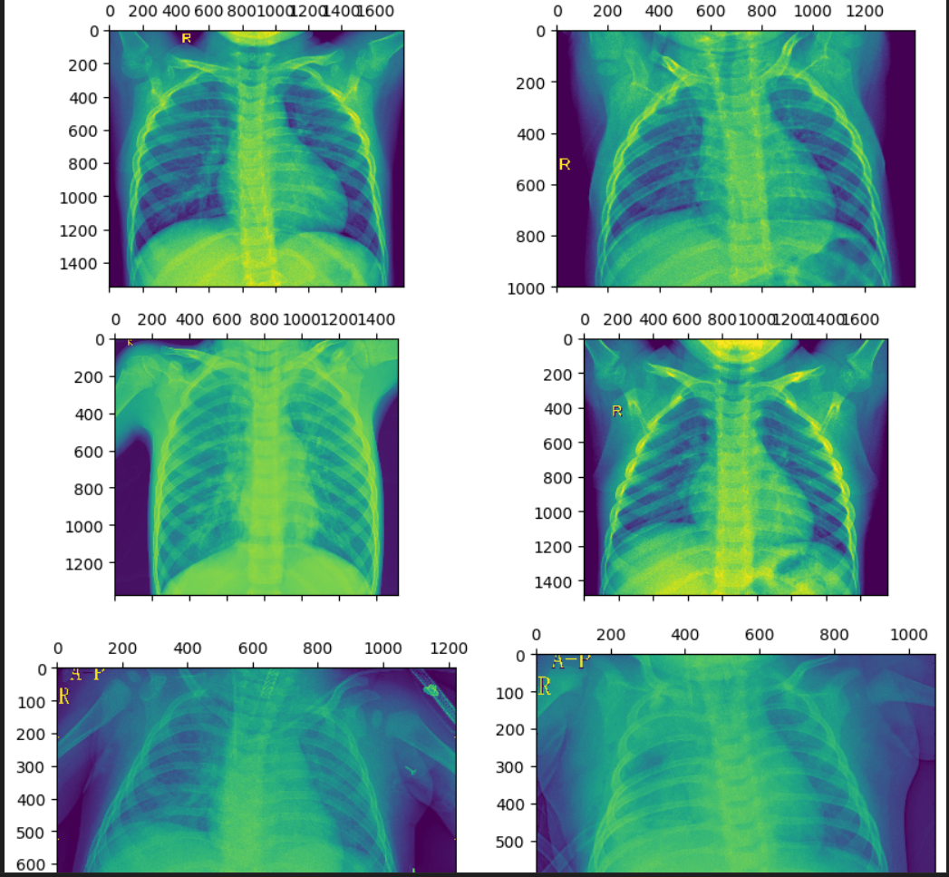

**Fig 1. Pneumonia**

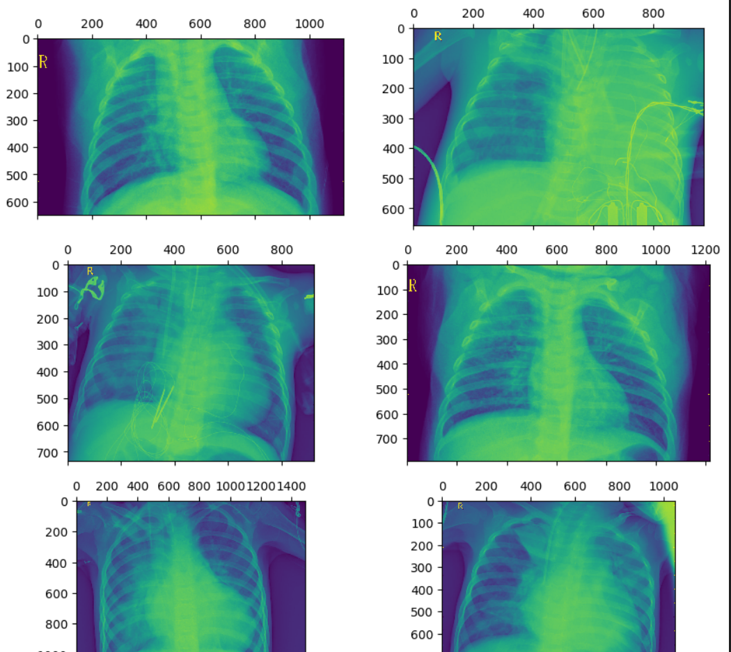

**Fig 2. Normal**

**Pneumonia detection model design**:

The working model is designed using many tools and technologies such as

Keras: Keras is a high-level neural networks API, written in Python and capable of running on top of popular deep learning frameworks like TensorFlow.

* Keras are User-friendly API that allows for fast experimentation with deep neural networks.
* Keras also Supports both convolutional networks and recurrent networks, as well as their combinations.

TensorFlow - TensorFlow is an open-source machine learning library developed by Google that allows developers to build and train neural networks. It was originally built for internal use at Google but was later released to the public in 2015. TensorFlow is widely used in various applications, including natural language processing, image recognition, and more.

* TensorFlow offers a flexible framework for building and training machine learning models.
* For faster training of models tensor flow support both cpu and gpu

OpenCV2, short for Open-Source Computer Vision Library version 2, is an open-source computer vision and machine learning software library. It gives a wide range of functions for real-time image and video processing, object detection, face recognition, and more. It has some key features which includes:

* Image manipulation and pre-processing
* Feature extraction and object tracking
* Machine learning algorithms for pattern recognition
* Integration with other libraries like NumPy and Matplotlib

Convolutional Neural Networks (CNNs) are a class of deep neural networks, most commonly applied to analysis for visual imagery. They are widely used in image and video recognition, natural language processing, and more. CNNs consist of multiple layers that learn to extract hierarchical features from data. some Key aspects of CNNs include:

* Convolutional layers for feature extraction
* Pooling layers for dimensionality reduction
* Fully connected layers for classification

NumPy and Pandas are essential things in Python for numerical computing and data manipulation, respectively. NumPy helps in providing support for arrays, matrices, and mathematical functions, while Pandas helps in data structures like Data frames and Series for efficient data analysis and manipulation. Together, they both the support systems of many data science projects by enabling:

* Data cleaning and pre-processing
* Statistical analysis and visualization
* Integration with machine learning models

Matplotlib is a comprehensive library for creating static, animated, and interactive visualizations in Python. It enables the creation of various types of plots, charts, and graphs to display data in a visually appealing manner. Some key features of Matplotlib include:

* Line plots, bar charts, scatter plots, and more
* Customization options for colors, labels, and annotations
* Exporting plots in different formats like PNG, PDF, or SVG

VGG19 is a well-known deep convolutional neural network structure recognized for its effectiveness in classifying images. It is composed of 19 layers with trainable parameters and has proven to be highly successful in numerous image recognition competitions. Some notable features of the VGG19 architecture comprise:

* Pretrained weights that enable rapid transfer learning.
* A sequential arrangement of convolutional and pooling layers.
* A relatively straightforward yet highly efficient design for extracting features.

A Convolutional Neural Network (CNN), also referred to as Conv-Net, is a deep learning algorithm specifically created for tasks such as object recognition. It has brought about a significant transformation in the field of computer vision by facilitating precise image analysis. The fundamental components of CNNs can be outlined as follows:

* Convolutional Layers: These layers are responsible for extracting characteristics from an input image while maintaining the interconnections between pixels through convolution.
* Deep convolutional generative adversal networks

**Train Model:**

The allocation of data for training and validation is an important factor in the model's performance. It involves deciding the percentage of data to be allocated to each set. Another crucial aspect is choosing the optimizer, such as Adam or SGD, which plays a significant role in adjusting the weights of the model. Additionally, determining the appropriate loss function, like binary cross-entropy, is essential for evaluating prediction inaccuracies. The learning rate strategy, including the initial value and schedule for adjustment, also needs to be carefully set. Lastly, deciding on the number of training epochs, which refers to the iterations over the training data, is crucial for achieving optimal results.

**Table:-**

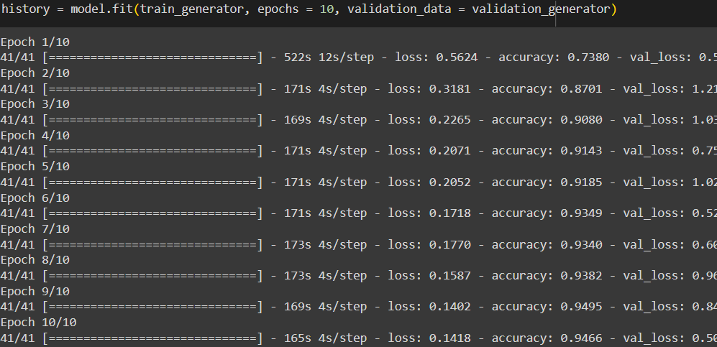

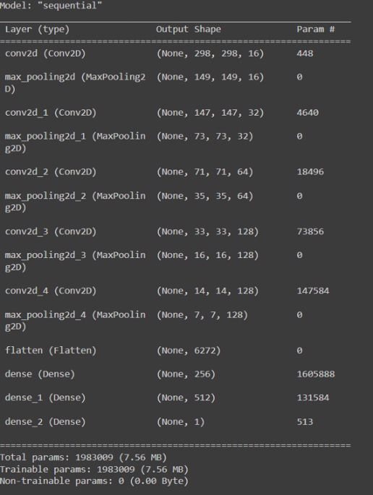

**Table 1.**

**Model Prediction:**

We monitored the model's performance during training using two key metrics: accuracy and loss. These metrics were visualized as line plots over training epochs (iterations over the training data) to assess the learning process. The accuracy plot (Figure 1) depicts the model's ability to correctly classify pneumonia and normal chest X-rays. As training progressed, the accuracy steadily increased, reaching a maximum of 95.1% at the end of training. This indicates the model's effectiveness in learning the patterns within the training data for pneumonia detection.

The loss plot (Figure 2) represents the model's training loss, which signifies the discrepancy between predicted and actual labels. Ideally, the loss should decrease over training epochs as the model refines its parameters to minimize prediction errors. The loss plot in Figure 2 demonstrates a consistent decline in training loss, reaching approximately 8% by the final epoch. This suggests the model's successful optimization during training, resulting in reduced prediction errors.

**Figures:-**

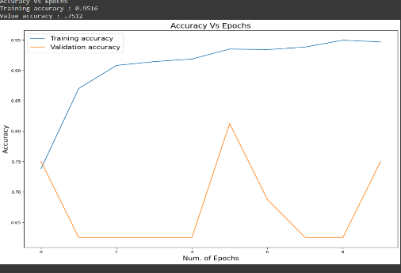

Fig1. Accuracy vs epochs

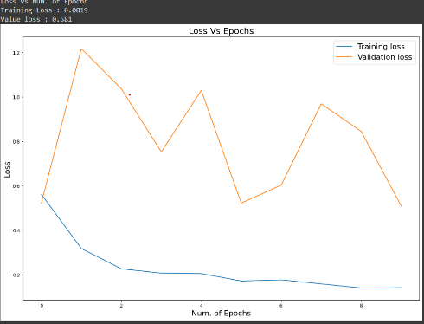

Fig 2. Loss vs epochs

1. **RESULTS**

To assess the model's effectiveness in pneumonia detection, we evaluated its performance on a separate test dataset not used during training. This approach helps ensure the model's generalizability to unseen data. The evaluation metrics employed were accuracy and loss. Accuracy reflects the model's ability to correctly classify pneumonia and normal chest X-rays. Loss represents the discrepancy between predicted and actual labels.The model achieved an accuracy of 93.56% on the test dataset, indicating its successful learning of pneumonia patterns from the training data. This accuracy demonstrates the model's potential for real-world application in assisting healthcare professionals with chest X-ray analysis. The model's loss on the test dataset was approximately 9%. While a lower loss is generally desirable, this value suggests the model can still make reasonably accurate predictions despite some discrepancies between predicted and actual labels.A threshold of 0.5 was employed for interpreting the model's predictions. Chest X-ray images with a predicted value above 0.5 were classified as pneumonia, while those below 0.5 were classified as normal. This threshold selection can be further optimized based on the specific application and desired balance between precision and recall.

**Figures:-**

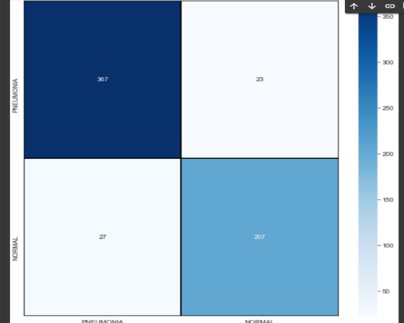

**Fig 1. Confusion matrix**

A confusion matrix serves as a tabular representation of a classification model's performance. It systematically organizes the number of correct and incorrect predictions made by the model

For example, if the image were a confusion matrix for a binary classification model, the cells labeled "367" and "207" would represent the number of correct predictions for the positive and negative classes, respectively. The cells labeled "27" and "23" would represent the number of incorrect predictions for the positive and negative classes, respectively.

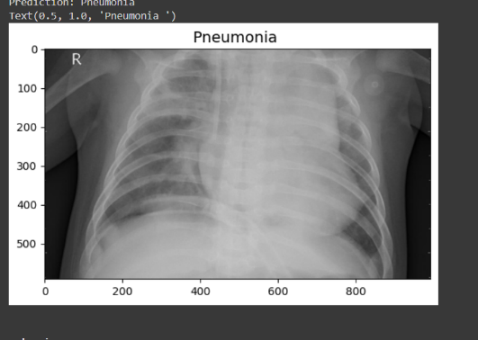

**Fig 2. Result showing Pneumonia**

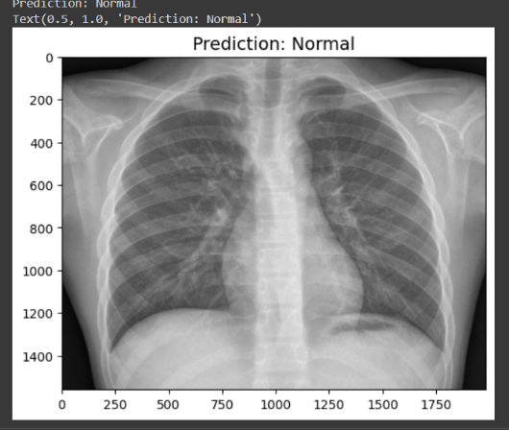

**Fig 3. Results showing Normal**

1. **CONCLUSIONS**

Early and accurate identification of lung infections is essential for diagnosing pneumonia. Traditionally, trained medical professionals examine chest X-rays, a process that can be time-consuming and may vary in consistency. This research proposes a new model for automating pneumonia detection using chest X-ray data.

The data, collected from various patients, was meticulously reviewed and categorized by medical experts. The model was trained on a large dataset of chest X-ray images using advanced computational techniques. The training process involved numerous iterations to optimize its performance. To evaluate the model's effectiveness, unseen chest X-ray images were used for testing. Metrics like classification accuracy, sensitivity, specificity, and F1 score were employed. The model achieved an impressive average accuracy of 94% in identifying pneumonia from these unseen images. These results suggest that this new approach holds significant promise for

improving the efficiency and consistency of pneumonia detection from chest X-rays.

1. **FUTURE SCOPE**

This study paves the way for a more versatile future in lung disease detection using chest X-rays. Expanding the model's disease recognition capabilities could transform it into a powerful diagnostic tool. This broader scope would empower clinicians to make faster, more accurate diagnoses, potentially leading to earlier interventions.

Furthermore, advancements in technology could unlock even greater performance. Increasing the model's complexity could enable the detection of less prevalent lung diseases, even in their early stages. Early detection is critical for successful treatment and improved patient outcomes.

However, this technology remains under development. While promising, it should be used alongside medical expertise. Further research and validation with larger datasets are needed before widespread clinical use. This future holds the potential for a more efficient and objective diagnostic process, ultimately improving patient care.

1. **REFERENCES**
2. Jyothi, A. P., Bharath, M. B., Raghu, V., Pavan, T., & Nath, H. (2023). Covid-19 detection using X-Ray images and fake X-Ray detection. In 2023 International Conference on Recent Advances in Science and Engineering Technology (ICRASET) (pp. 1-6). IEEE.
3. Jindal, V., Kukreja, V., Singh, D. P., Vats, S., & Mehta, S. (2023). Reinventing respiratory diagnostics: Federated learning & CNNs in pneumonia classification. In 2023 4th IEEE Global Conference for Advancement in Technology (GCAT) (pp. 1-6). IEEE.
4. Warrier, M. M., Abraham, L., & Resmi, R. (2023). An optimal deep ensemble model for the classification of pneumonia from chest X-rays. In 2023 14th International Conference on Computing Communication and Networking Technologies (ICCCNT) (pp. 1-7). IEEE.
5. Shourie, P., Anand, V., & Gupta, S. (2023). An efficient CNN framework for radiologist level pneumonia detection using chest X-ray images. In 2023 3rd International Conference on Intelligent Technologies (CONIT) (pp. 1-6). IEEE.
6. Mazumdar, S. D., Kumar, A., & Sethuraman, R. (2023). Pneumonia detection using chest X-ray images using CNN algorithm. In 2023 7th International Conference on Intelligent Computing and Control Systems (ICICCS) (pp. 496-501). IEEE.
7. He, Z., Ren, Y., & Wang, H. (2023). Optimizing dataset configuration for improving convolutional neural networks performance in chest X-ray image classification. In 2023 8th International Conference on Intelligent Computing and Signal Processing (ICSP) (pp. 1166-1173). IEEE.
8. Setiawan, A. W. (2022). The effect of image dimension and exposure fusion framework enhancement in pneumonia detection using residual neural network. In International Seminar on Application for Technology of Information and Communication (iSemantic) (pp. 41-45). IEEE.
9. Desai, V., & Thengade, A. (2022). Chest abnormality detection from X-rays using deep learning. In Second International Conference on Next Generation Intelligent Systems (ICNGIS) (pp. 1-6). IEEE.
10. Mishra, S., Hazra, A., & Prakash, U. M. (2022). Pneumonia detection using deep learning. In 2nd International Conference on Advance Computing and Innovative Technologies in Engineering (ICACITE) (pp. 2163-2167). IEEE.
11. Ranpariya, D., Parikh, P., Patel, M. I., & Gajjar, R. (2022). A CNN based hybrid model for pneumonia classification using chest X-ray images. In 2nd International Conference on Artificial Intelligence and Signal Processing (AISP) (pp. 1-7). IEEE.